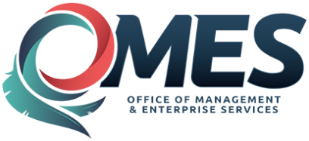 |  | Statewide Contract  Addendum

This addendum is added to and is to be considered part of the subject contract.

Statewide Contract #: | SW0023B
PeopleSoft Contract ID: | # 3944
Contract Title: | Drug Testing Products and Services
Contract Issuance Date: | 12/17/2014
Contract Supplier: | See below
Addendum # | Nine (9)
Addendum Date: | October 28, 2019
OMES Point of Contact:
Contracting Officer: | Theresa Johnson
Phone Number: | 405-521-2289
E-mail address: | theresa.johnson@omes.ok.gov
Addendum Information:
The contract period expiration date has been extended through 09/30/2020. In accordance with MMCAP contract MMS14033, amendment #20.

0000252752
Redwood Toxicology Laboratory
Santa Rosa, CA

If you have any questions concerning the addendum contact the above contracting officer.

