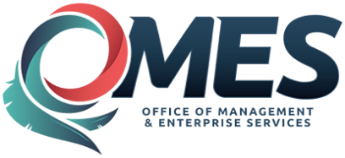 |  | Notice of Statewide Contract Award

Official signed contract documents are on file with OMES-Central Purchasing.
Contract Title: | Accessiblity Software and Related Services
Statewide Contract # : |  | SW |  |  |  |  | 1063
Contract Issuance Date: |  | 10/13/2017
Total Number of Vendors: |  | 1 |  |  |  |  |  |  |  |  |  |  |  | (For details see: Vendor Information Sheet)
Contract Period: |  | 08/31/2017 |  |  |  |  |  |  |  |  |  |  |  |  |  | through |  |  | 06/01/2018
Agreement Period: |  | 08/31/2017 |  |  |  |  |  |  |  |  |  |  |  |  |  | through |  |  |  | 06/01/2021
Authorized Users: |  | All State Departments, Boards, Commissions, Agencies and Institutions,  in addition to Counties, School Districts and Municipalities which may  avail themselves of this contract.
Contract Priority: |  | Non-mandatory Statewide
Type of Contract: |  | % DIscount off of MSRP and fixed rate
OMES-CP Contact: |  | Rickey M. Thomas |  |  |  |  |  |  |  |  |  |  |  |  |  |  | Title: |  |  |  |  | Procurement Specialist
Phone: |  | 1 |  | - |  | 405 |  |  | - |  | 522 |  | - |  | 8160 |  |  | Email: |  |  |  |  | Rickey.Thomas@omes.ok.gov

