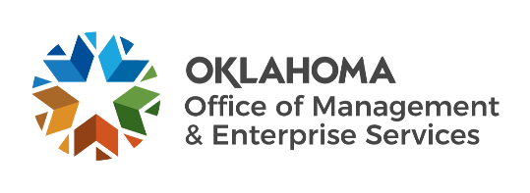 |  | Statewide Contract  Addendum

This addendum is added to and is to be considered part of the subject contract.

Statewide Contract #: | SW0035
PeopleSoft Contract ID: | 6479
Contract Title: | Vehicles
Contract Issuance Date: | 02/08/2021
Contract Supplier: | Reynolds Ford
Addendum # | 15
Addendum Date: | 06/06/2022
OMES Point of Contact:
Contracting Officer: | Cristy Newton
Phone Number: | (405) 521-6721
E-mail address: | cristy.newton@omes.ok.gov
Addendum Information: | Pricing update
Addendum 15 is issued to update pricing from Confidence Ford.

