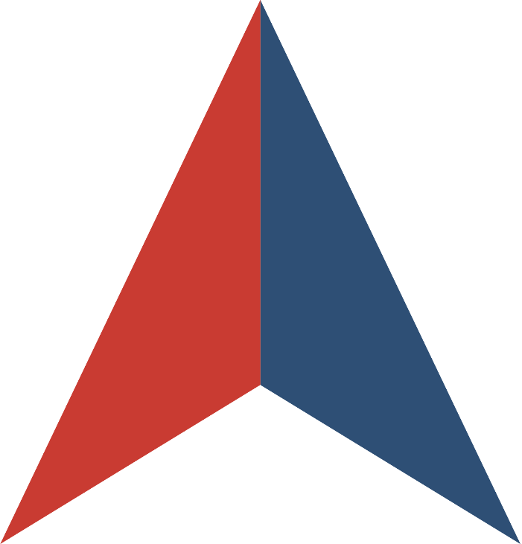
REQUEST FOR PROPOSALS
for
HEAVY CONSTRUCTION & INDUSTRIAL EQUIPMENT

Issued by
THE STATE OF OKLAHOMA

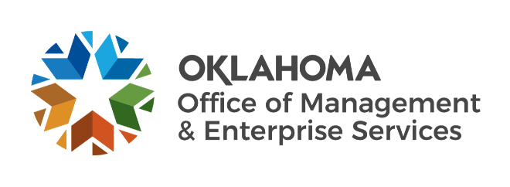

In collaboration with


SOLICITATION NUMBER OK-MA-192-23
RFP WEBSITE: ok.gov/dcs/solicit/app/solicitationDetail.php?solID=4415
RFP OVERVIEW

- OVERVIEW
This Request for Proposals (RFP) is being issued by the of State of Oklahoma (“Lead State”), Office of Management and Enterprise Services, in collaboration with the NASPO ValuePoint cooperative purchasing program. The purpose of this RFP is to establish one or more Master Agreements with manufacturers of new heavy construction and industrial equipment. Collectively, these Master Agreements will constitute the NASPO ValuePoint Construction Equipment Portfolio.
The purpose of this competitive solicitation is to develop a “catalog category discount” contract to provide for equipment to be made available for purchase. Only Manufacturer Suppliers with dealer networks in many states are asked to bid directly on the contract. The contract will be a multiple award contract for both equipment and warranty work with replacement parts.

About NASPO ValuePoint
NASPO ValuePoint is a division of the National Association of State Procurement Officials (NASPO), a non-profit association dedicated to advancing public procurement through leadership, excellence, and integrity. In accordance with NASPO ValuePoint’s Lead State Model™, the Lead State is issuing this RFP, evaluating responses, and establishing Master Agreements with the support and assistance of a Multistate Sourcing Team™ composed of individuals from other member states, representing a broad range of perspectives that ensure the RFP incorporates best practices recognized by public entities across the country.

Participation in NASPO ValuePoint Master Agreements is convenient and cost-effective for eligible entities—including state departments, institutions, agencies, and political subdivisions, federally recognized tribes, and other eligible public and nonprofit entities in the 50 states, the District of Columbia, and U.S. territories—and suppliers, with no membership or registration required. In 2021, contractors reported a combined $16.94 billion in sales through NASPO ValuePoint Master Agreements awarded through cooperative solicitations like this RFP, including a combined $31.03 million in sales through the current Construction Equipment portfolio.

More information about NASPO, NASPO ValuePoint, and the NASPO ValuePoint Lead State Model can be found at www.naspo.org and www.naspovaluepoint.org and in Attachment E, Participation Information.
- GENERAL INFORMATION AND INSTRUCTIONS
  - Important Dates.
    - RFP Open Date: December 19, 2022 (Monday)
    - RFP Q&A Deadline: January 16, 2023 (Monday) by 3:00pm Central Time
    - RFP Close Date: January 30, 2023 (Monday) by 3:00pm Central Time
Dates and deadlines are subject to change. Offerors should continue checking the RFP Website for the most up-to-date information.
  - RFP Contact. The following individual is the sole contact for this RFP:
Asha Parks
Contracting Officer/Procurement Specialist
Email - asha.parks@omes.ok.gov

State of Oklahoma, OMES Central Purchasing
2401 N. Lincoln Blvd.,
Oklahoma City, OK 73105

  - Contract Term. The initial term of the master agreement shall be from the date of award for two (2) years with the option to renew for three (3) additional one-year periods.
D. Renewals Prior to any renewal, the Lead State shall subjectively consider the value of the Contract, the Supplier’s performance and review of current pricing and discounts offered by Supplier. If it is determined changes to the Master Agreement are required as a condition precedent to renewal, the Lead State and Supplier will cooperate to evidence such required changes in an Addendum.

E. Extensions. The Lead State may extend the Master Agreement for ninety (90) days beyond a final renewal term. If exercised, the Lead State shall notify Supplier in writing prior to expiration date. The Lead State, and to the extent allowable by law, may choose to exercise subsequent ninety (90) day extensions at the Agreement pricing rate, to facilitate the finalization of relater terms and conditions of a new award or as needed for transition to a new Supplier.

F. RFP Website. The following website is the sole official source for RFP information and updates:
Link / URL --- ok.gov/dcs/solicit/app/solicitationDetail.php?solID=4415
G RFP Documents. This RFP consists of this RFP Summary, the following attachments, and any information or materials posted by the Lead State to the RFP Website, as amended:
- Attachment A, RFP Terms and Conditions
- Attachment B, Scope of Work
- Attachment C, RFP Evaluation Plan
- Attachment D, Sample Master Terms and Conditions
- Attachment E, Potential Participation
- Attachment F, Protest Information
- Attachment G, Offeror Information, Acknowledgements, and Certifications
- Attachment H, Offeror Response Worksheet
- Attachment I, Cost Proposal
- Attachment J, Proposed Modifications to Sample Master Agreement
- Attachment K, Claim of Business Confidentiality
- Attachment L, Value Add Plan
- Attachment M, Authorized Dealers Listing
- Attachment N, Past Performance Reference Survey

H How to Ask Questions.
    - Read and review this RFP, including all attachments, exhibits, and amendments.
    - For questions about the content of this RFP, please submit them in writing via email to Asha Parks at asha.parks@omes.ok.gov by the deadline (date and time shown) in Section II.A. Questions submtitted after this deadline will not be answered. Answers will be publicly given via the State of Oklahoma Solicitation site as an amendment to the RFP as soon as practicable. Questions must reference the specific section of the RFP to which the question relates.
    - The identity of prospective Offerors will not be published with the answers, but the text of questions will be restated, so Offerors are cautioned about including context in questions that may reveal the source of questions.
  - How to Respond.
    - Read and review this RFP, including all attachments, exhibits, and amendments.
    - Prepare a proposal that:
      - Follows the requested format.
      - Includes the Solicitation Number on all materials making up the proposal.
      - Addresses each question and request for a response in this RFP, including all questions in Attachment H, Offeror Response Worksheet.
      - Clearly demonstrates your ability to meet the Scope of Work described in Section III and Attachment B; and
      - Includes all required submissions identified in Section IV.
    - Submit your proposal by the RFP Close Date. All responses must be sent electronically to: OMESCPeBid@omes.ok.gov

Proposers are solely responsible for ensuring that their Proposals are received by the Lead State in accordance with these solicitation requirements, before the closing date and time, and sent to email reference above. No paper copies will be accepted.
at the place specified on the cover sheet of this RFP.

- SCOPE OF WORK
A detailed description of the Deliverables being sought through this RFP is attached as Attachment B, Scope of Work.
The scope of this RFP and its resulting Master Agreement(s) is intended to benefit all state departments, institutions, agencies, and political subdivisions and other eligible public and nonprofit entities in the 50 states, the District of Columbia, and U.S. territories. Therefore, Offerors should not interpret the Scope of Work to be associated with or limited to any specific purchase, implementation, project, need, or program within the Lead State or any other state or eligible entity. Proposals should be generally applicable to all potential Participating and Purchasing Entities, except where specificity is requested.
- OFFEROR RESPONSE
  - Required Submissions. All responses are required to be submitted directly through to OMESCPeBID@omes.ok.gov The following must be submitted with your proposal:
- Completed and signed Attachment G, Offeror Information, Acknowledgements, and Certifications
- Completed Attachment H, Offeror Response Worksheet
- Completed Attachment I, Cost Proposal, submitted as a separate document and separate file.
- Completed Attachment J, Proposed Modifications to Sample Master Agreement
- Completed and signed Attachment K, Claim of Business Confidentiality
- Completed and signed Attachment L, Value Added Plan
- Attachment M, Authorized Dealers & Distributors Listing
- Attachment N, Past Performance Surveys (3)
- OMES Form CP076, Responding Bidder Information
- OMES Form CP004, Certification for Competitive Bid and/or Contract (Non-Collusion Certification).
- Redacted copy of proposal clearly marked as such, if claiming confidential, proprietary, or protected information.
- Redlined copy of Attachment D, Sample Master Agreement, if proposing modifications

  - Other Documents. The following are informational only and do not need to be submitted with your proposal:
    - Attachment A, RFP Terms and Conditions
    - Attachment B, Scope of Work
    - Attachment C, RFP Evaluation Plan
    - Attachment D, Sample Master Agreement
    - Attachment E, Potential Participation
    - Attachment F, Protest Information
- EVALUATION AND AWARD PROCESS
  - Proposals will be sealed until the RFP Close Date. After opening, proposals will be evaluated in stages as set forth in this section and further detailed in Attachment C, RFP Evaluation Plan.
    - Stage 1: Initial Responsiveness. Proposals will be reviewed for completeness and initial responsiveness. Proposals omitting required documents or responses may be rejected in accordance with Attachment A, RFP Terms and Conditions.

    - Stage 2: Mandatory Minimum Requirements. Proposals meeting initial responsiveness requirements will be evaluated against the Mandatory Minimum Requirements set forth in Attachment C, RFP Evaluation Plan. Proposals meeting all Mandatory Minimum Requirements will proceed onto the Stage 3: Techncial Criteria Evaluation.

    - Stage 3: Technical Criteria. Proposals meeting all Mandatory Minimum Requirements will be evaluated against the Technical Criteria set forth in Attachment C, RFP Evaluation Plan. All responses which scored at least 75% of available points will move on to the Stage 4 Cost evaluation.

    - Stage 4: Cost Evaluation. Cost Proposals not rejected following evaluation of Technical Criteria will be evaluated. Costs will be scored into three Categories as detailed further within Attachment C – RFP Evaluation Plan. Cost Proposals may also be subject to an independent review for reasonableness and best value by the Lead State.

    - All weighted scores will be totaled to arrive at the supplier’s total scored evaluation.

    - In accordance with Oklahoma Statutes, 74 O.S. § 85.5, the State of Oklahoma reserves the right to negotiate with one, selected, all or none of the Offerors responding to this solicitation to obtain the best value for the Lead State. Negotiations could entail discussions on products, services, pricing, contract terminology or any other issues that mitigate the Lead State’s risks. The Lead State will consider all issues negotiable and not artificially constrained by internal corporate policies. Negotiation may be with one or more Offerors, for any and all items in the Offeror’s Proposal.

Firms that contend that they lack flexibility because of their corporate policy on a particular negotiation item may face a significant disadvantage and may not be considered. If such negotiations are conducted, the following conditions shall apply:

Negotiations may be conducted in person, in writing, or by telephone.

Negotiations will only be conducted with Offerors’ that submitted potentially acceptable Proposals. The State reserves the right to limit negotiations to those Proposals that received the highest rankings during the initial evaluation phase.

Terms, conditions, prices, methodology, or other features of the Offeror’s Proposal may be subject to negotiations and subsequent revision. As part of the negotiations, the Offeror may be required to submit supporting financial, pricing, and other data in order to allow a detailed evaluation of the feasibility, reasonableness, and acceptability of the Proposal.
    - It is anticipated that this RFP may result in Master Agreement awards to multiple contractors, at the Lead State’s discretion. The evaluation process is designed to award the contract resulting from this RFP to the Supplier deemed to be the most responsive and responsible concerning requirements outlined in the Technical Requirements.
  - After evaluations are completed, the Lead State and Multistate Sourcing Team will determine which proposals are most advantageous to the Lead State and potential Participating and Purchasing Entities. Awards will be made at the natural break of high and low scores.
  - Prior to announcement of awards and execution of Master Agreements, the Lead State will present an award recommendation to the NASPO ValuePoint Executive Council for approval of the proposed awards.
  - Following approval of the NASPO ValuePoint Executive Council, the Lead State will issue an intent-to-award announcement on its electronic procurement system. Proposal files are public records and available for review at the offices of the Lead State by appointment.

