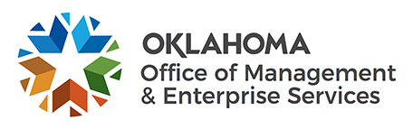 | Agency Acquisitions Exceeding $100,000 Quarterly Report
This form shall be submitted quarterly to the Central Purchasing Division for the purpose of reporting any contracts exceeding $100,000 awarded by a state agency pursuant to 74 O.S. §85.5(T). Report due dates are: March 31; June 30; September 30; and December 31st.
Submit form to: CP.feedback@omes.ok.gov
Agency Name: |  |  | Agency Number: |  |  |  |  |  |  | Report Date:
Purchase Order Number | Supplier/Vendor |  |  | Description of Purchase |  |  |  |  |  | Total Purchase Amount |  |  | Contract Start Date | Contract End Date
 |  |  |  |  |  |  |  |  |  | $
 |  |  |  |  |  |  |  |  |  | $
 |  |  |  |  |  |  |  |  |  | $
 |  |  |  |  |  |  |  |  |  | $
 |  |  |  |  |  |  |  |  |  | $
 |  |  |  |  |  |  |  |  |  | $
 |  |  |  |  |  |  |  |  |  | $
 |  |  |  |  |  |  |  |  |  | $
 |  |  |  |  |  |  |  |  |  | $
Comments:
The undersigned, being authorized to sign and file this report on behalf of the agency named herein, hereby affirms: (1) the contracts listed in this report were awarded in accordance with applicable state laws and OMES/Central Purchasing administrative rules; (2) the agency has subject matter experts on staff with the specialized expertise to purchase the goods or services described herein; (3) the agency possesses the necessary legal and procurement staff to procure and monitor the contracts; and (4) the Director of the Office of Management and Enterprise Services issued a certification that the purchase(s) did not conflict with consolidated statewide spend initiatives prior to contract award.
Name of Person Filing Report: |  |  |  |  | Title: |  |  |  | Telephone:
Signature |  |  |  |  |  |  |  |  |  |  | Date

