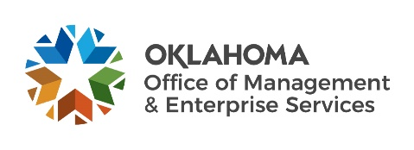 |  | Supplier Performance  Evaluation
Complete this form in evaluating the level of performance of an awarded supplier when doing business with the State of Oklahoma. Please verify all information to ensure accuracy, as all necessary details must be furnished to ensure proper monitoring of supplier performance to achieve an informed and equitable evaluation of services provided. Performance evaluations become a permanent record of the supplier and to serve as a reference for a contractor’s performance.
References related to performance evaluations are: Title 74 O.S. § 85.7.(C); 74 O.S. § 85.39.(C), 74 O.S. § 85.41.(B), and OAC 260:115-1-2, OAC 260:115-7-32.(g), OAC 260:115-9-1.(h)

AGENCY INFORMATION
Name: |  |  |  |  | Agency number:
Address: |  |  |  |  | City/State/Zip:
Contact Person: |  |  |  |  | Email Address:

SUPPLIER INFORMATION
Name: |  |  | PeopleSoft ID number:
Address: |  |  | City/State/Zip:
Contact Person: |  |  | Email Address:

ORDER INFORMATION
Acquisition Type: | Service(s) |  |  | Product(s)

This evaluation covers the acquisition period from: | Month | / | Day | / | Year | to | Month | / | Day | / | Year

Acquisition process: | Fixed Rate | Sole Source | Agency Bid | OMES Bid | Interagency
 | GSA |  |  |  | Statewide
Statewide Contract #:: |  |  |  |  |  |  | Item number:
Delivery Date of Last Shipment: |  |  |  |  |  | Purchase Order #
LEVEL OF SERVICE (If “No” please explain in the comments section.)
1. Did the deliverable meet the specifications? |  | Yes |  | No
2. Was the deliverable on time? |  | Yes |  | No
3. Was the deliverable on budget? |  | Yes |  | No
4. Was the contractor responsive to your needs? |  | Yes |  | No
5. Were there any issues after the fact? |  | Yes |  | No
6. Would you use the contractor again? |  | Yes |  | No
Comments:
Desired resolution and include any additional supporting data :
Submission of this form and questions shall be sent to: CP.Feedback@omes.ok.gov

