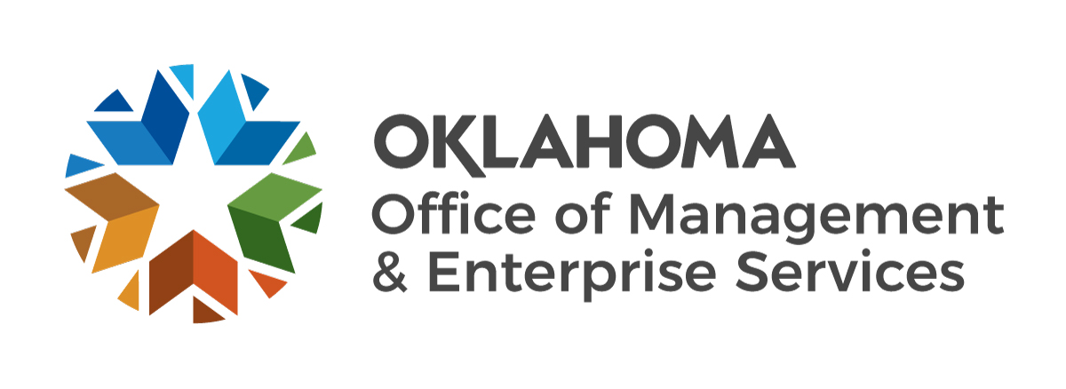 |  | State Purchase Card Program  Employee Agreement

The undersigned, as an approved purchase card (P-card) holder, state agency P-card Administrator or back-up administrator, or state agency approving official or back-up approving official, fully understand and agree to the following terms and conditions regarding the use and safekeeping of the P-card(s) entrusted to me:
- I accept full personal responsibility for the safekeeping of all P-cards assigned to me, and I understand that absolutely no one, other than myself, is permitted to use the P-card(s) assigned to me.
- I understand I will be making financial commitments on behalf of the State of Oklahoma and will obtain fair and reasonable prices;
- I have received training and agree to follow all procedures established for use of the P-card;
- I shall not use the P-card for any non-state related business, unauthorized purchases, personal purchases, or cash advances or approve any such purchases or advances;
- I will immediately report the theft or loss of the P-card to Bank of America at (888) 449-2273, my agency approving official and agency P-card Administrator;
- I understand the use of the P-card does not exempt me from requirements to obtain certain supplies from required sources as set forth in statutes and P-card procedures;
- I shall surrender my P-card(s) upon (a) transfer to another organization of state government; (b) termination of employment with the state; or, (c) request of my supervisor, agency approving official, agency P-card Administrator or the State Purchasing Director or designee;
- I understand any purchases made by me or approved by me shall be recorded and reviewed in management reports, for payments, and possible discrepancies and appropriateness of purchase. Further, I acknowledge that I shall have personal liability for any inappropriate purchases made by me or approved by me and agree to reimburse the State for such purchases; and will abide by Ethics Commission Rules;
- I understand I cannot use the P-card as a financial reference to obtain personal credit cards or loans;
- I understand I am personally responsible for obtaining all or requiring all purchase and credit documents (i.e., receipts, receiving documents, disputes, etc.) and submitting them in accordance with State P-card Procedures;
- I will use the P-card only within the limits and restrictions placed upon it unless the state agency P-card Administrator or State P-card Administrator has temporarily lifted the limits and restrictions due to an emergency situation or other unique circumstance;
- The approving official agrees to review billings for each billing cycle in accordance with the State P-card Procedures and immediately report any discrepancies, inappropriate purchases, or any knowledge of violations of the items enumerated above to the state agency P-card Administrator and the State P-Card Administrator.
- I understand failure to follow any of the above listed terms & conditions or, if found to have misused the P-card in any manner, may result in (a) revocation of the privilege to use the P-card; (b) disciplinary action; (c) termination of employment; and/or (d) criminal charges, being filed with the appropriate authority.
My P-card program role is: | ☐ Cardholder |  |  | ☐ Approver |  | ☐ P-card Administrator
Cardholder name (printed/typed) |  |  | Cardholder signature |  |  |  |  |  |  | Date signed
As approving official or back-Up approving official, or state agency P-card Administrator or back-up P-card Administrator, I hereby agree to the above terms and conditions and take full administrative responsibility pursuant to the State of Oklahoma Purchase Card Procedures for the action(s) of the cardholder(s).
Cardholder approving official name (printed/typed) |  |  | Cardholder approving official signature |  |  |  |  |  | Date signed
State agency P-card Administrator (printed) |  |  | State agency P-card Administrator (signature) |  |  |  |  |  |  | Date signed

RECEIPT FOR P-CARD
Printed name of cardholder:
Dollar and transaction limitations for this cardholder:
Dollars per transaction*
Dollars per cycle (“month”)
*There is no P-card transaction limit for purchases from a statewide contract, utilities, interagency payments, and professional services as defined in Title 18 O.S. §803. Any other state P-card transaction shall not exceed five thousand dollars ($5,000.00).
I have reviewed and understand the dollar limitations on my P-card and I acknowledge receipt of the P-card.
Employee signature |  |  |  |  |  |  |  |  |  |  |  | Date card received
P-card Account No. (Last 6 digits only):
Verification No. (Last 4 digits only):
State agency and Division/Department:
Cardholder Telephone Number:
Cardholder Work Location:
 | Office Address |  |  |  |  |  |  | City & State |  |  |  |  |  |  |  |  | Zip Code
Approving Official:
 |  |  | Name |  |  |  |  |  |  |  |  |  |  | Phone
The state agency P-card Administrator or state agency back-up P-card Administrator must complete and maintain the following information for each p-cardholder, state agency P-card Administrator, state agency back-up P-card Administrator, state agency approving official, and state agency back-up approving official.

Initial OMES Training Date: |  | Card Order Date:
Initial Agency Training Date: |  | Card Cancellation Date:
Periodic Internal Training Date: |  | Card Compromise Date:
Periodic Internal Training Date: |  | Date Works Account Deactivated:

Periodic Internal Training Date:

Periodic Internal Training Date:

Periodic Internal Training Date:

Periodic Internal Training Date:

Periodic Internal Training Date:

Periodic Internal Training Date:

Periodic Internal Training Date:
 |  | Employee Termination Date:
 |  | Card Destruction Date:

Copy of completed form and/or card receipt provided to agency employee on

